Rochester Institute of Technology
Department of Computer Engineering
CMPE-630 Digital IC Design
Spring 2025
Laboratory Exercise 2
Inverter Schematic and Simulation
Due: 1/31/2025
Contents
1 Introduction 2
2 Procedure 3
2.1 Create the Schematic 3
2.2 Create a Symbol 4
2.3 Optional - Creating a Verilog Model 6
2.4 Simulate the Circuit (Pre-Layout) 8
2.5 Starting Analog Environment 10
2.6 Example For Test Measurements 18
2.7 Creating Your Own Tests to Collect Data 30
3 Questions 38
4 Lab Exercise Report Requirements 39
5 Signoff Sheet 41

Introduction
This exercise will teach you how to design a CMOS inverter, convert custom circuits to symbols, and create a proper testbench for pre-layout simulation of basic CMOS logic gates.
Op | tional
: There are also instructions on how to create a Verilog model (see section 2.3). This part is an artifact left over from previous semesters and is not required for signoffs.
Check section 4 for the lab report requirement and section 5 for the required items for signoff.
Please | sub | mit | your | lab | re | port | (with | the | sig | noff | sheet | at | tached) | to | my | Courses
Disclaimer: The instructions for this lab were made with an older version of Cadence Virtuoso
Keep the following in mind as you work through this lab.
- NEVER COPY CADENCE LIBRARY FILES FROM THE COMMAND LINE OR FILE MANAGER
- IF ANY OF YOUR CADENCE FILES ARE LOCKED, CLOSE THE TOOL AND EXECUTE THE FOLLOWING COMMAND:
/class | es/ee620/bin/unlock cadence.csh
- Hotkeys: You should learn how to use the hotkeys for better productivity. You can access a list of hotkeys (also known as bindkey) from CIW (the first window that pops up after you launch virtuoso). In CIW, select the menu option:
Op | tions | → | Bind | key
Select a category (e.g. schematic) and a list of current hotkeys (bindkeys) will be shown for it.
REMINDERS:
- Always start the Cadence tools using the virtuoso & command from your cmpe630 directory and NOT from your home directory.
- Always properly close the Cadence tools before you log off, otherwise you WILL lose your work and/or potentially lock your cells and not be able to access them!

Procedure

Create the Schematic
Reminder: ‘fml’ is an example for first, middle, last name. Please use your initials!
In your previous exercise you learned how to make an schematic. This time you will do it on your own (Don’t worry, it’s a simple inverter). To start, create a new cell in your personal cell library. Go to the Library Manager window, select your library fml lib and then select File → New → Cellview. This time, you will name your cell “FML INVX1” and make sure the view is set to schematic. Continue following the same instructions from the previous lab exercise.
When sizing the transistors, make sure you change the sizing values! The NMOS has a length of 45nm and total width of 120nm, PMOS has length of 45nm and total width of 240nm. Check and save your schematic and check the CIW for log messages that your schematic is clean. You should receive a “schematic check completed with no errors” and your final schematic should look like Fig. 1.
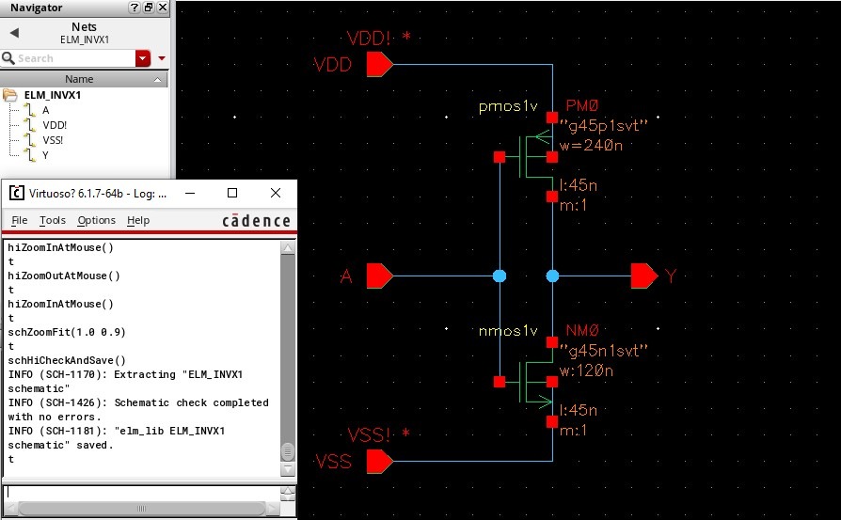.
Figure 1: Final Schematic
If you receive warnings or errors, you need to fix these issues before proceeding!
The TAs and lab instructor will be checking your final inverter schematic and clean CIW output message for Signoff

Create a Symbol
Do not close your schematic capture window. Create a symbol view by selecting Create → Cellview → From Cellview, and the following (see Fig. 2 should appears).
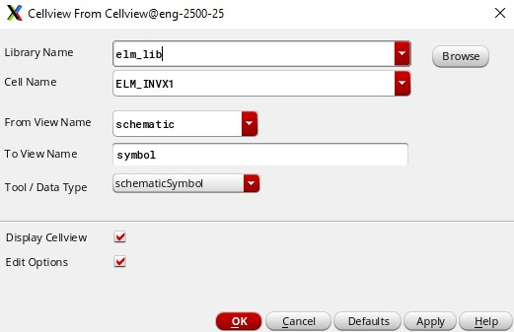.
Figure 2: Create Schematic Symbol Cellview from Cellview Form
Ex | clude | In | her | ited | Con | nec | tion
Click OK and an options window will appear, shown in Fig. 3. Here, select the option All under Pins and ensure that VDD and VSS are present within the field.
Click OK to create the symbol view.
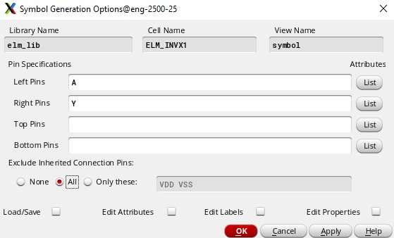
Figure 3: Symbol Generation Options
Now your new symbol will appear as shown in Fig. 4.
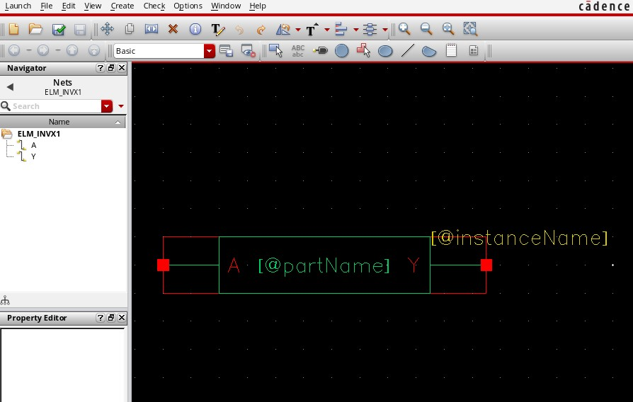
Figure 4: New Symbol Cellview
Edit the symbol to appear more like a gate as shown in Fig.5. ONLY edit the cell outline - the green portion of the symbol - not the symbol parameters. (This will make your final project more understandable and easy to debug).
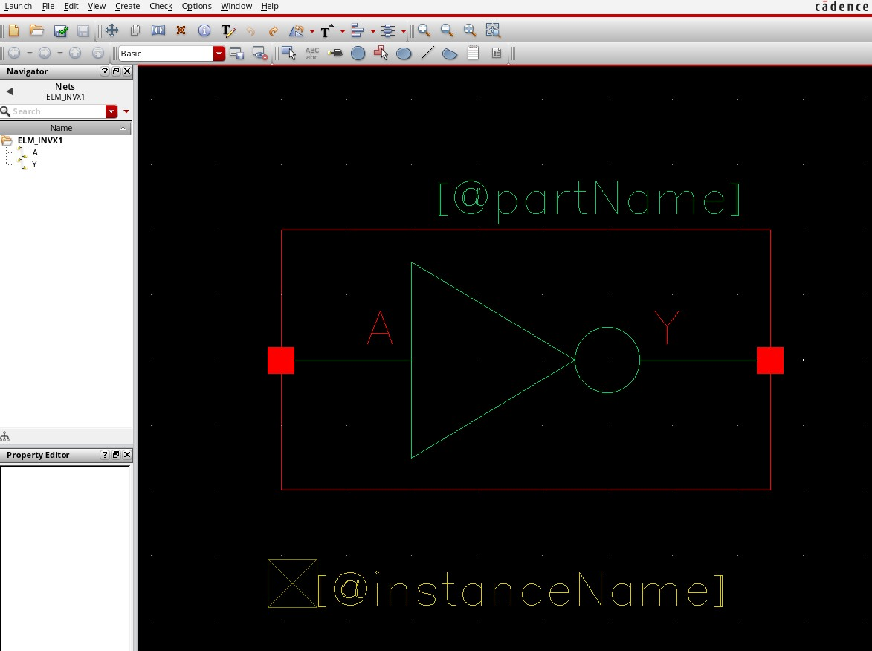
Figure 5: Edit Symbol Cellview
check | and
You can now save and close the symbol. Note that you may receive warnings about the missing VDD and VSS pins which you can ignore.
You can use your new symbol by instantiating it in a schematic. Before moving on, close your symbol window.

Optional - Creating a Verilog Model
This section is optional. Feel free to move on to the next section.
Using your schematic capture window, create a Verilog view by selecting Create → Cellview → From Cellview. Make sure that the “From File View” name targets schematic and change the “Tool/Data Type” to Verilog-Editor.
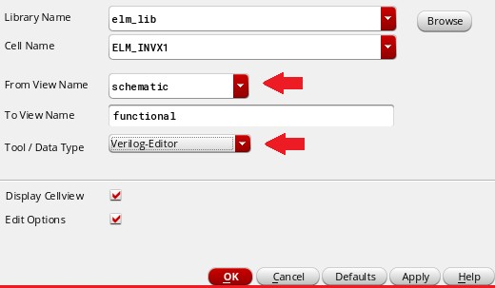.
Figure 6: Create Verilog HDL Cellview from Cellview Form
Click OK and a text editor will appear.
NOTE: You may receive a warning message window indicating that your symbol and Verilog module have pin mismatches. This warning can be safely ignored. DO NOT regenerate your symbol to fix the noted pin issues. (The mismatch occured due to VDD and VSS pins being intentionally not added to your symbol; they do however appear in your Verilog module and schematic. We keep it this way so you can safely use your symbol in other schematics without any VDD and VSS
attached.)
Take a look at the pins shown in the module declaration. Your model should have the same pins.
Your screen should be identical to the window shown in Fig.7
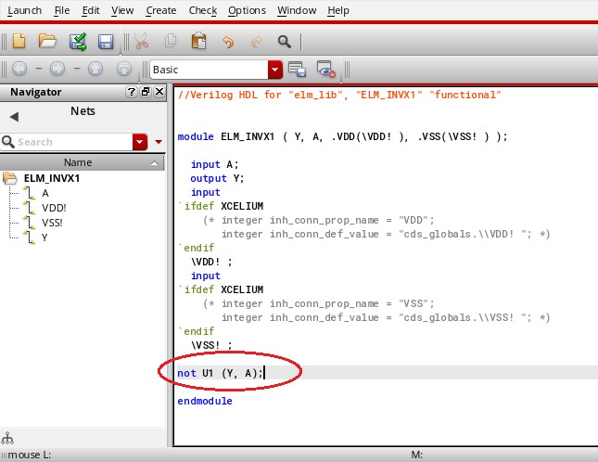.
Figure 7: Verilog HDL Cellview
Check and Save the code. You might have same warning mentioned above in “NOTE:”, please follow the same instructions. DO NOT regenerate your symbol to fix the noted pin issues!
You will receive a syntax report in your CIW that should indicate your code is clean as shown below.
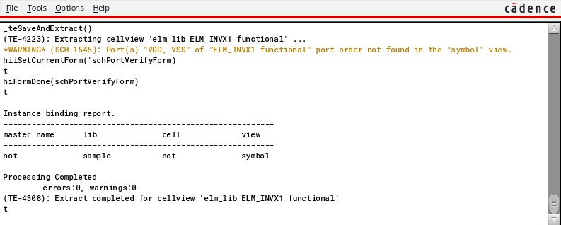.
Figure 8: Check and Save Verilog HDL Cellview CIW Log Messages
Close your Verilog model; next we’ll simulate your circuit with Spectre, a high performance Spice like simulator.

Simulate the Circuit (Pre-Layout)
The advanced simulation environment requires a ”testbench” for the device under test (DUT or the circuit you wish to simulate). Using the Library Manager, create new schematic cellview and
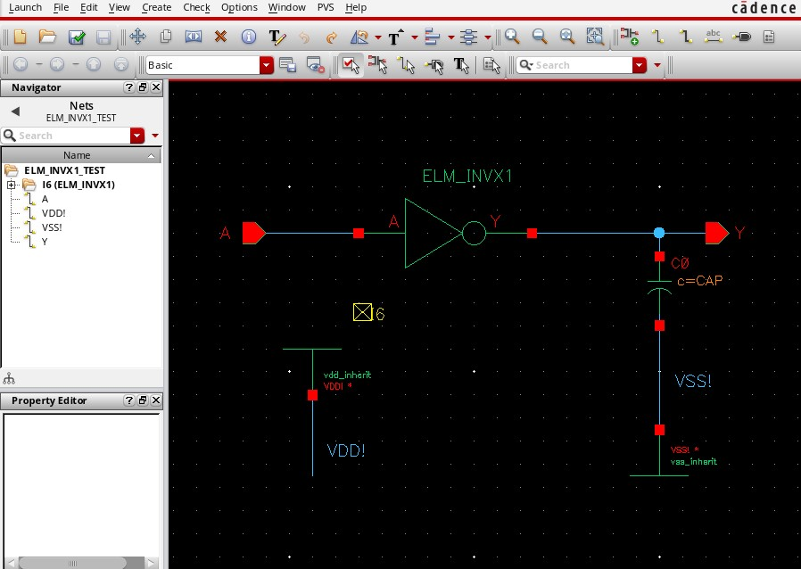
nameitFML
INV1
TEST.DesignyourschematicasshowninFig.9
.
Figure9:ELM
INVX
TESTTestbenchSchematic
Place one instance of your inverter cell. Next, add a capacitor form the analog library. Click browse on the Add Instance and select the analog library analoglib, and then the capacitor cap. The Add Instance form should update as shown in Fig.10.
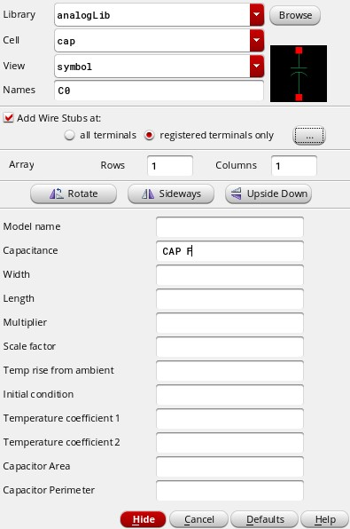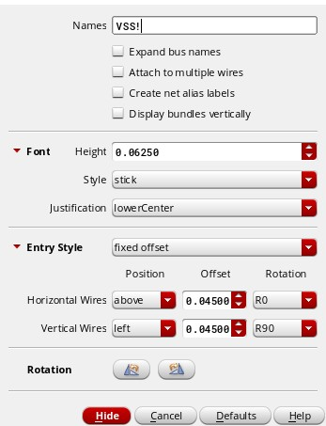
Figure 10: Add Capacitor instance to Schematic
Form Figure 11: Create Wire Label for VSS Form
We are going to create a capacitor variable so we can modify the value for future tests. Modify the Capacitance value to CAP F, and hit the tab key. Then click Hide/OK.
Take a look at Fig.11. VDD and VSS need special treatment; add the cells vdd inherit and vss inherit from the analog library. Wire these cells as shown and then add wire labels using Create → wire → name. Note that adding the cells is first, wiring is second and adding labels are as the last step. The following shows creating the label VSS!.
Attach the label to the appropriate net. Check and save your schematic. Again, the final product should look like Fig. 9.

Starting Analog Environment
We’ll now start the analog environment, Select Launch → ADE XL from your testbench schematic.
You’ll get the following window:
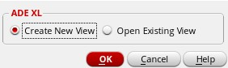
Figure 12: Launch ADE XL
Click OK. Then a window to create the new ADE XL view will appear, shown in Fig.13. Then Click OK.
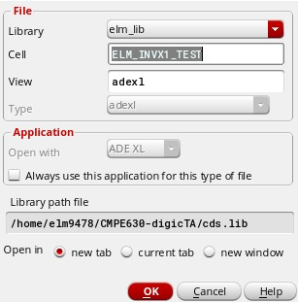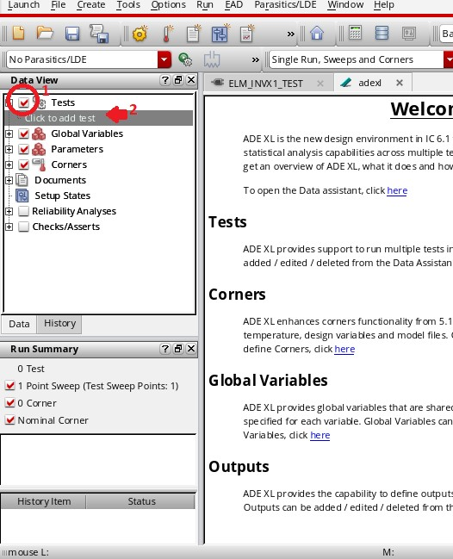
Figure 13: Create new ADE XL View Form Figure 14: Initial ADE XL Testbench Window
”Click | to
add | test”
The welcoming page will show up shown in Fig.14. To the left, click on Tests and then in the Data View window.
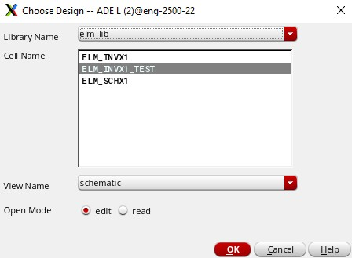
Figure 15: ADE XL Test Editor Window
Once the test editor window opens, you’ll be prompted to select your test bench design shown in
Fig.15. Now, click OK and you will see the test editor window. (see Fig. 16)
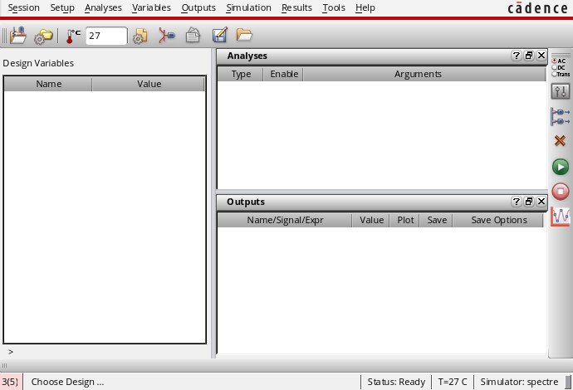
Figure 16: ADE XL Test Editor Window
Setup | → | High
Per | for | mance | Sim | u | la
APS mode is enabled for simulation by default, and we will turn that off. Selecttion and the following window will appear (see Fig 17).
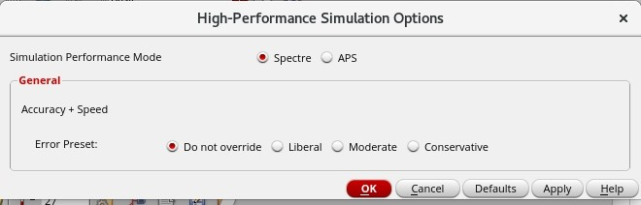
Figure 17: High Performance Simulation Options
Spec
Be sure to select tre for the simulation performance mode, your test results might be invalid otherwise.
We’ll then tell the simulator which “section” of the transistor models we are going to use - model files typically have multiple sections representing “corners”, such as fast / fast or minimum (ff), typical (tt), and slow / slow or maximum (ss). Select Setup → Model Libraries and the following window will appear (see Fig. 18) .
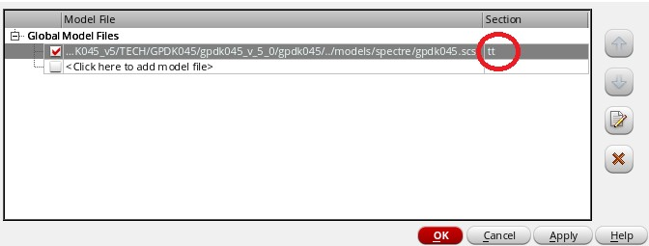
Figure 18: Configure Model Files Form
Be sure to select the model tt in the section box. Click OK.
Now, go to Setup → Stimuli
Select Inputs, enable input A and change its function to pulse, make sure Enabled is checked. Complete values as shown in Fig.19.
Click apply. (If you don’t “Apply” your changes wont save and you will encounter errors!) Input A is now enabled!
Now select Global Sources and complete the configuration form as shown in Fig.20.
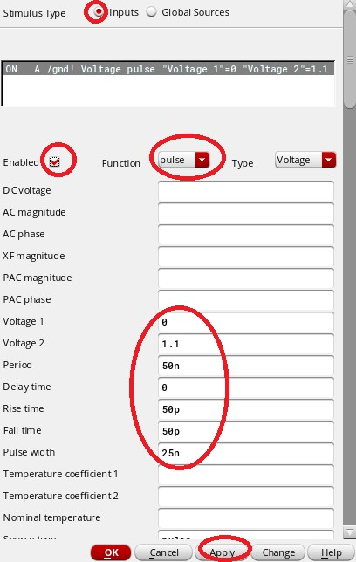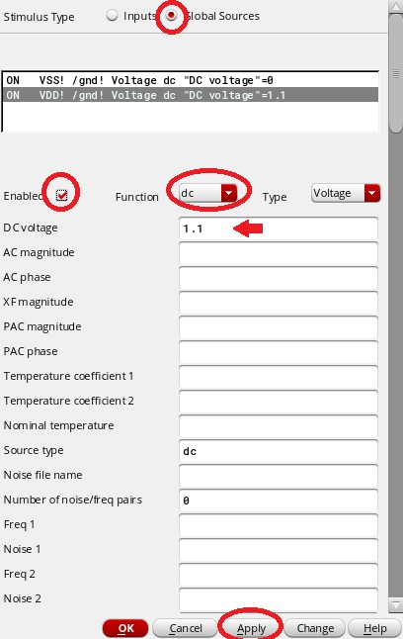
Figure 19: Configure Input Stimulus Form Figure 20: Configure Input Stimulus Form
Click OK to close this selection window.
Now select Analysis → Choose, and fill out the next window as shown in Fig. 21
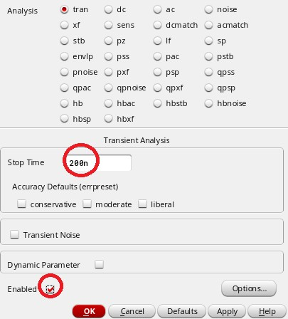
Figure 21: Configure Analysis Form
Select tran (Transient Analysis) and set Stop Time to 200n (200 nanoseconds).
Click Enabled and then click OK.
Now we need to select the outputs to be saved and plotted. Select Outputs → To Be Plotted → Select On Design (Depending on the context, the menu pick may show as Outputs → To Be Plotted → Select On Schematic). In the schematic window, click once on the circuit nodes you want plotted. In this case input A and output Y. You’ll notice the nets change colors as shown below (see Fig. 22).
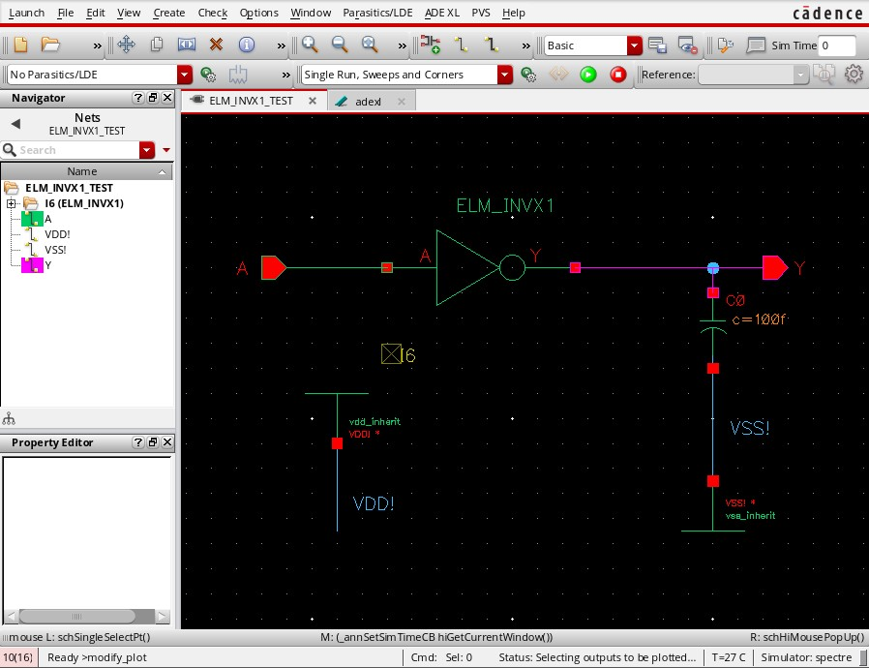
Figure 22: Schematic with Signals Selected for Plotting (ignore the capacitor value, it should be c=CAP)
After you make the selections, make sure you press ESC to avoid leaving the plot command active in the schematic capture window.
From | Cel
Now, let’s add CAP as a design variable (CAP is the capacitance variable we made in the testbench schematic). Underneath the Design Variable window in your test editor, right-click and select Copy lview (see Fig. 23). Then enter the 100f as the corresponding value for CAP.
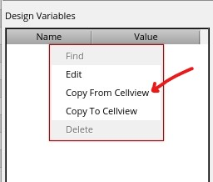
Figure 23: Copy from cell view
Once that’s done, your test editor should look like the following (See Fig. 24).
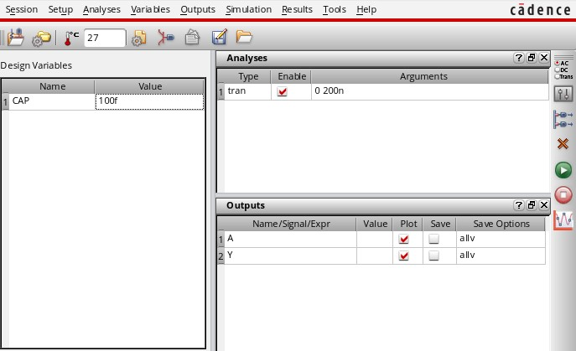
Figure 24: ADE XL Test Editor Window - Configuration Complete
Se | lect | Session →
Quit and now you will return to the ADE XL window (Select ‘adexl’ if necessary).
Your adexl window should look like this.
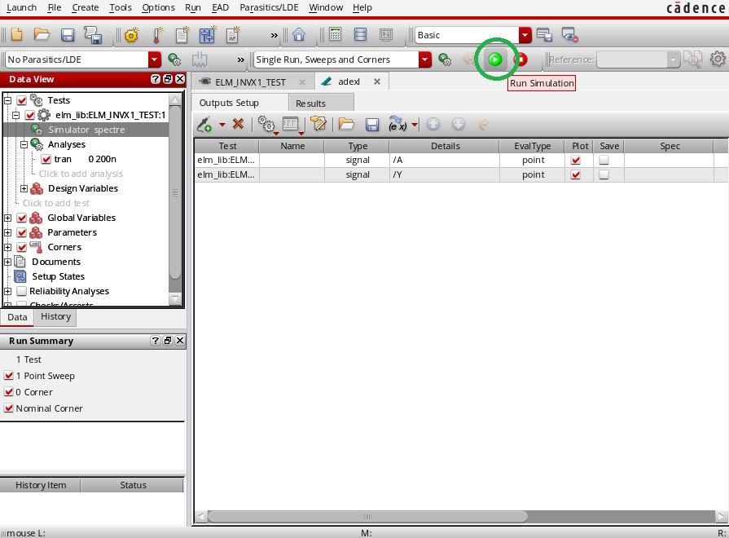
Figure 25: ADE XL Main Window - Configuration Complete
You are ready to run your first transient simulation! Click on the green start icon (see Fig. 25). The tools will generate a netlist of your schematic which is used by the simulator to create the admittance matrix of the circuit. The simulator solves the matrix, then saves and plots the results.
Once your simulation is successful, you’ll see new waveform indicators on the results tab as shown below.
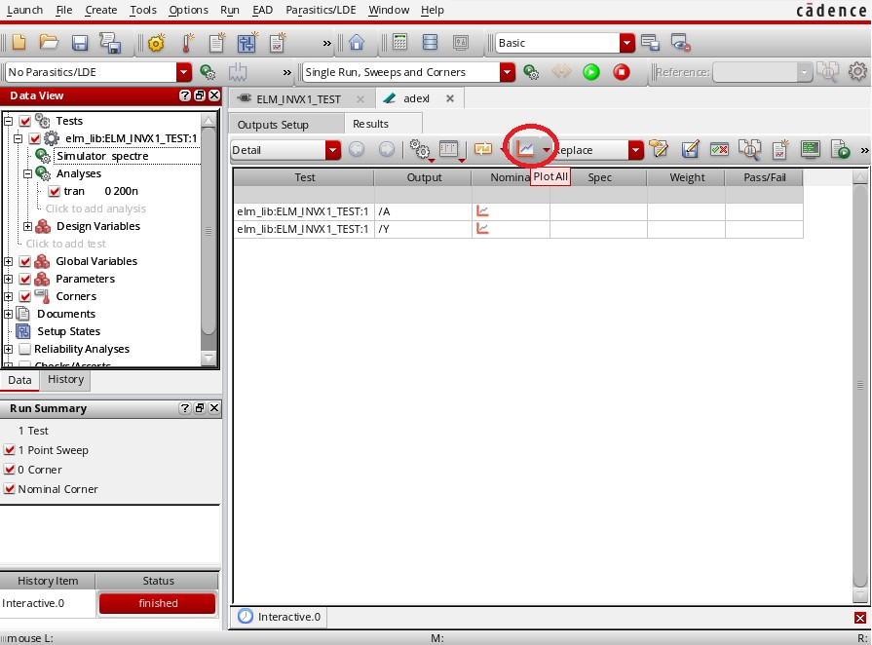
Figure 26: ADE XL Test Editor Window - Simulatoin Complete
Plot
Click on the little graph icon ( all) as shown in Fig. 26. The waveform window will then be opened as shown in Fig. 27.
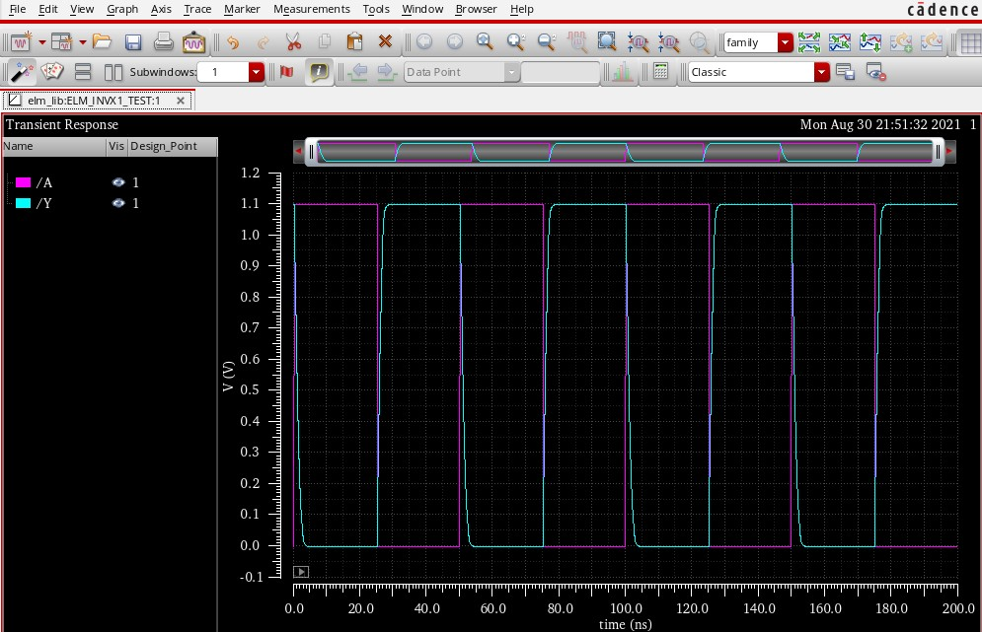
Figure 27: ADE XL Waveform Window - Overlapping Waveforms
The waveforms will initially be overlapped; click on the “Split All Strips” icon to separate your waveform into strips as shown below (see Fig. 28):
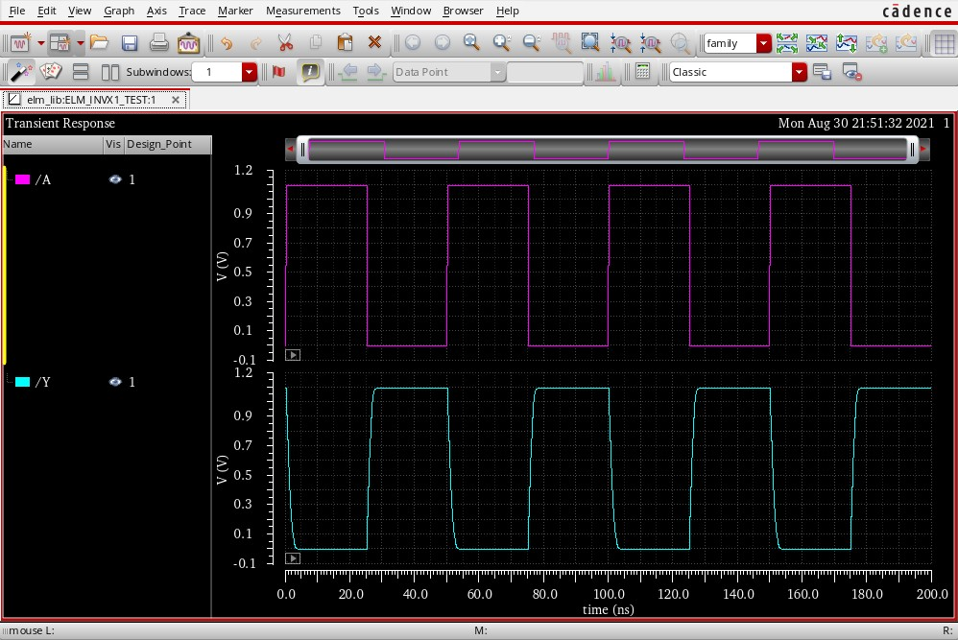
Figure 28: ADE XL Waveform Window - Strip Waveforms
Use the zoom icons to zoom in and out of the displayed area as shown below (see Fig. 29):
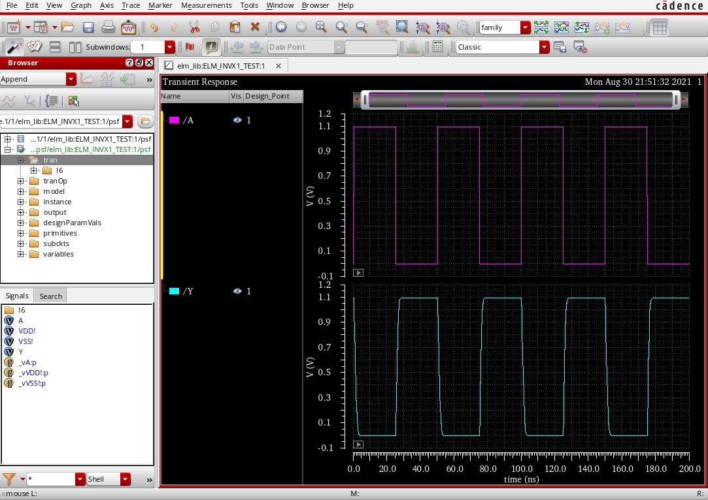
Figure 29: ADE XL Waveform Window - Zoom Into Waveforms
This is the transient simulation signoff. Please also do take a screen capture of some waveform plots for your report (You’ll thank yourself later).

Example For Test Measurements
The ADE XL Waveform viewer provides a powerful suite of tools to perform analysis and calculations using the simulator outputs. From the waveform window, open the design Browser using the menu pick Browser → Results → Open Results. Select the PSF database as shown below (see Fig.
30).
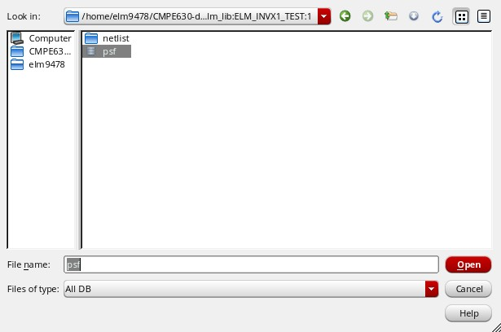
Figure 30: ADE XL Select Waveform Database Form
Click Open.
The Browser panel opens on the left of the waveform window; using the upper browser panel, navigate and select tran as shown in Fig. 31. Signals will appear in the lower browser panel, select the output Y, right click, and open the calculator (again, see Fig. 31).
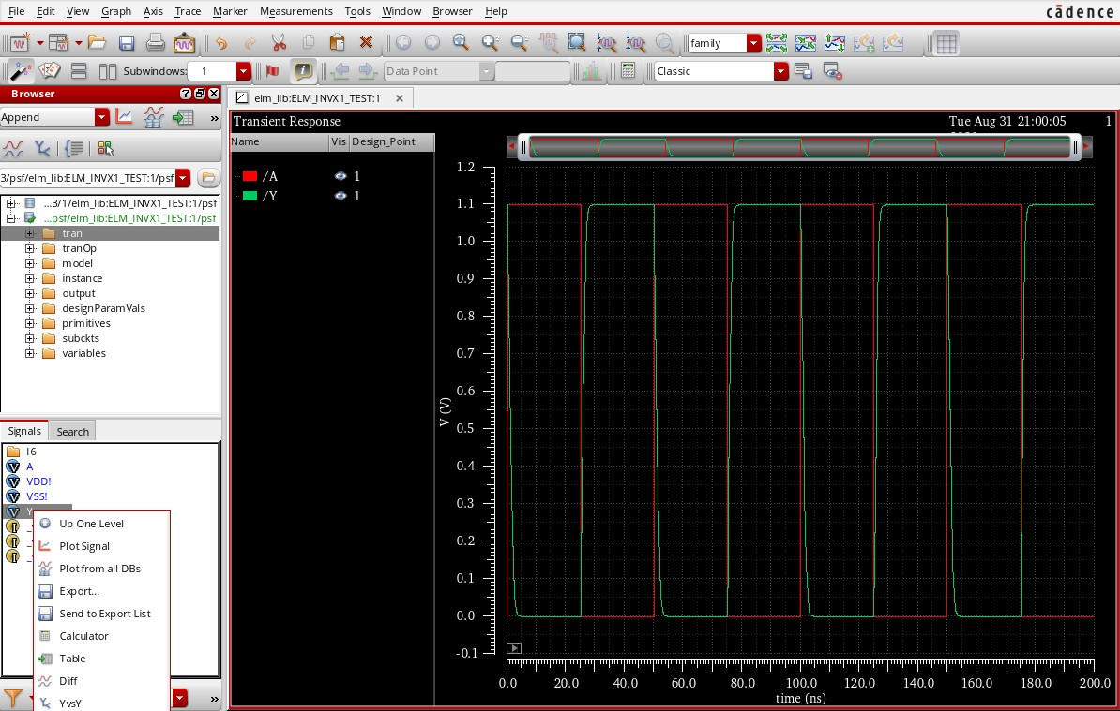
Figure 31: Waveform Window with Hierarchy Browser Panel
The calculator will open just like below (see Fig. 32).
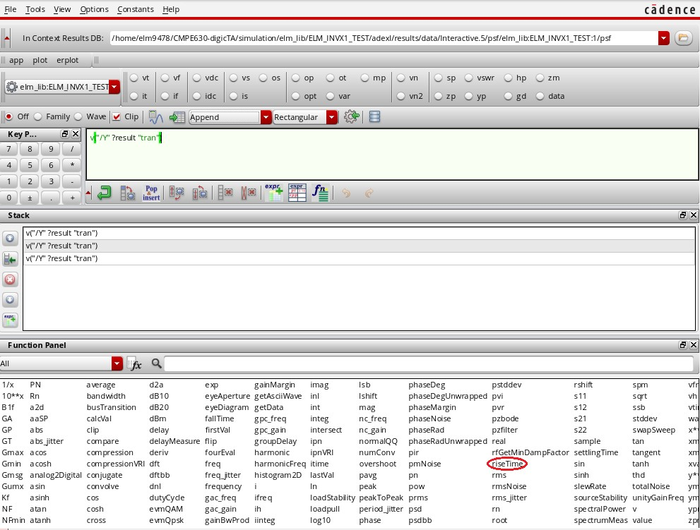
Figure 32: Waveform Window with Hierarchy Browser Panel
rise | Time.
Now, lets calculate the pre-layout output signal rise time. From the function panel, select
Set the initial value of Y to 0, and the Final Value of Y to 1.1 as shown in Fig. 33. For this tutorial, we’ll define Rise and Fall time as the time it takes a single pass from 10% to 90% of the signal swing. As such, we’ll set the Percent Low to 10 and the Percent High to 90 in the form as shown in Fig. 33.
Fall | Time | cal | cu | la
Note: Percent Low and Percent High are defined differently for tion. We will remind you about this later in the lab :)
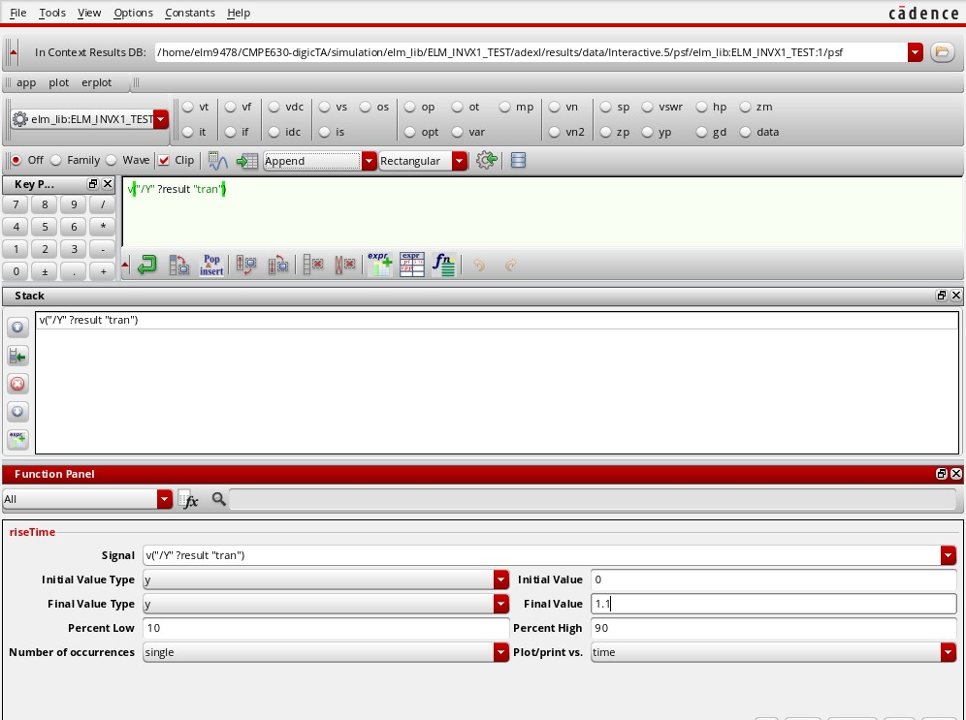
Figure 33: Waveform Calculator Window - Rise Time Calculation Function
Once the form is updated, click Apply to enter the expression into the calculator buffer (see Fig.
34).
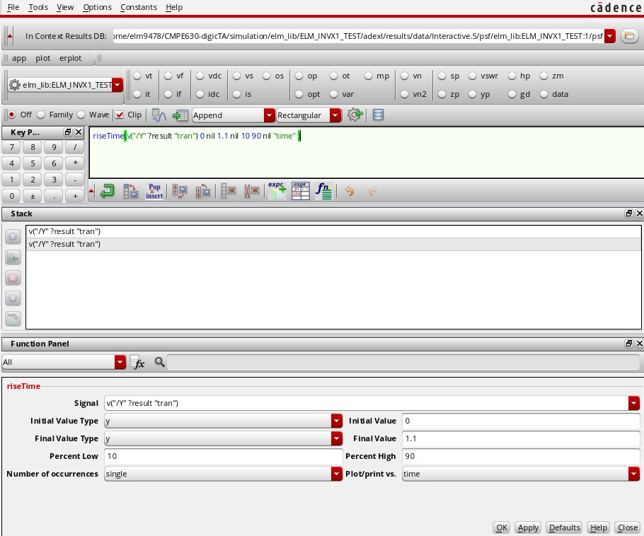
Figure 34: Waveform Calculator Window - Rise Time calculation Function
Once entered, we can evaluate out expression in the calculator buffer by clicking on the evaluate icon as shown below (see Fig. 35).
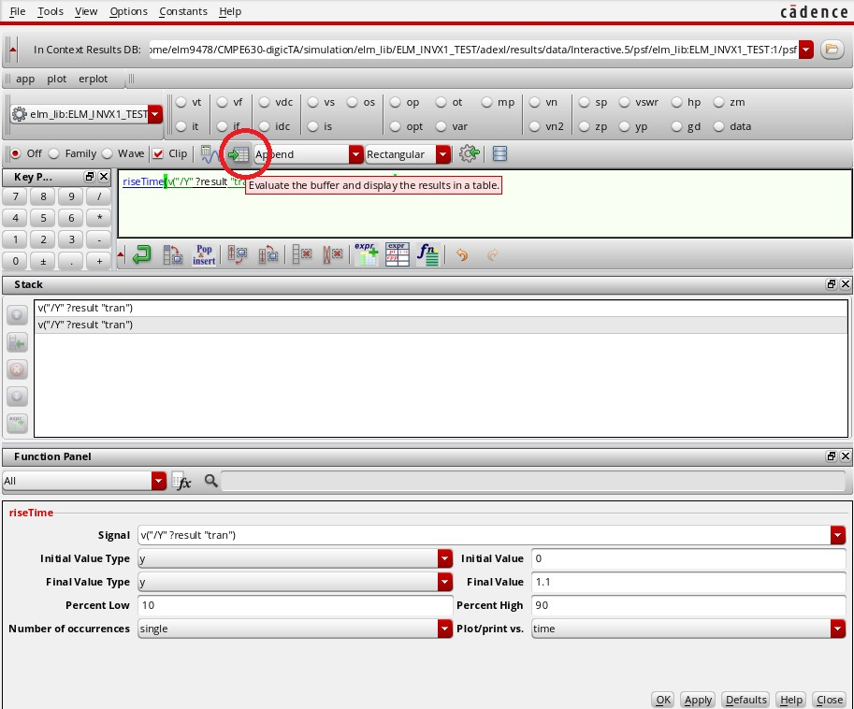
Figure 35: Waveform Calculator Window- Rise Time calculation Function
And the rise time is calculated as shown below (see Fig. 36).
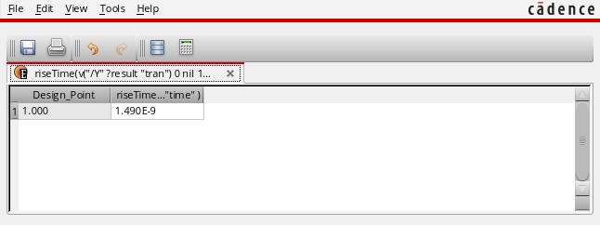
Figure 36: Waveform Calculator Window- Rise Time Calculation Results
Now that we have the rise time value, we can improve our efficiency with the tools by adding this (or any valid calculator expression we desire) to the ADE-XL output setup tab. Return to the calculator and towards the bottom of the window click on the Expression Editor tab as shown in Fig. 37.
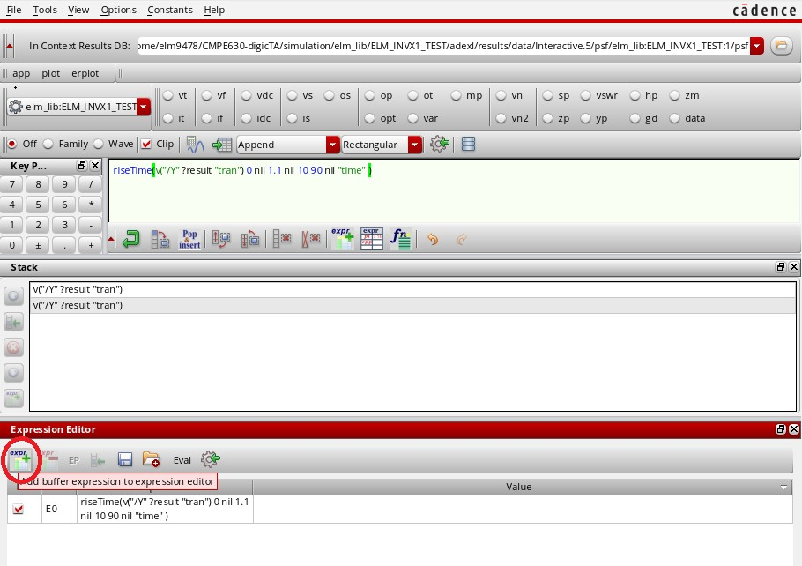
Figure 37: Waveform Calculator Window- Rise Time calculation Expression Editor
The name E0 is not very descriptive, so let’s rename the expression as RiseTime Y
When renaming expressions during future projects, note not all characters are supported, so check the CIW for errors if your expression name is not accepted.
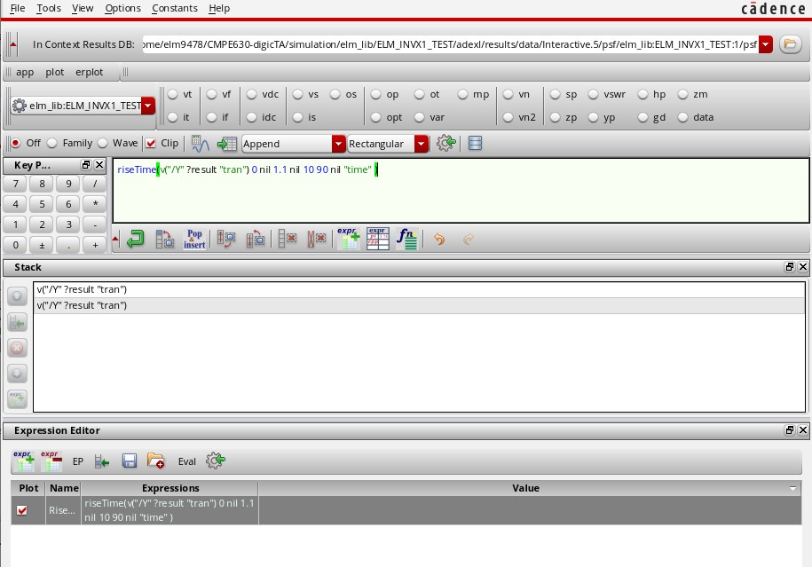
Figure 38: Waveform Calculator Window- Rise Time calculation Expression Editor - Rename Expression
Send | se | lected | ex | pres | sions | to | ADE | out | puts.
Now Click the little gear icon (see Fig. 39) to
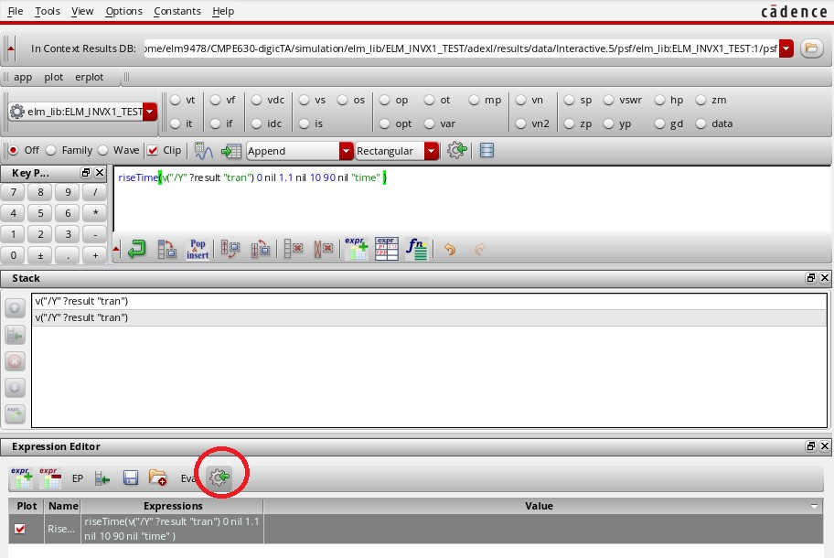
Figure 39: Waveform Calculator Window- Rise Time calculation Expression Editor - Export Expression
As shown in Fig. 40, the rise time calculation expression now appears as an output in the Outputs Setup tab; the expression will be evaluated once the simulation runs.
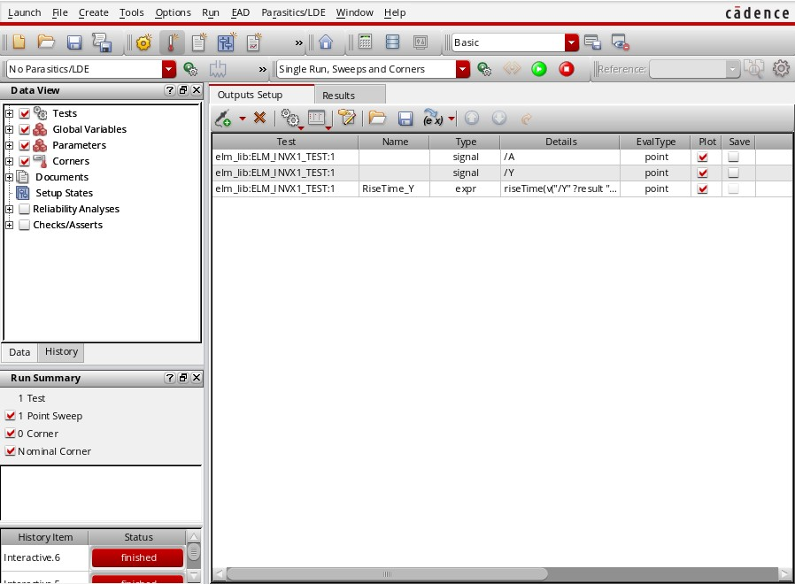
Figure 40: ADE XL Test Editor Window - Outputs Setup with Rise Time Calculation Expression
You are now ready to re-run your transient simulation. Click on the green start icon.
Once the simulation has run, the result of the expression is added to the Results tab (see Fig.
41).
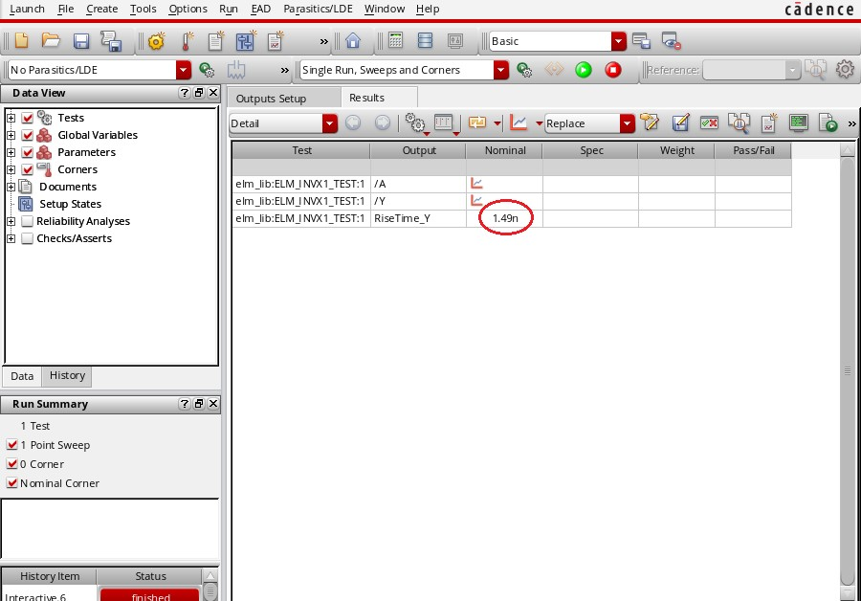
Figure 41: ADE XL Test Editor Window - Results with Rise Time Calculation Result
Then you can close the calculator results, calculator and waveform windows.
Now we want to add DC sweep simulation to plot the Inverter voltage transfer characteristics (VTC) curve. Note that this could be done for most types of gates, but you have to keep all inputs fixed for the one that is swept.
So that we don’t have to enter all of the setup again, we’ll make a copy of our initial test as shown in Fig. 42:
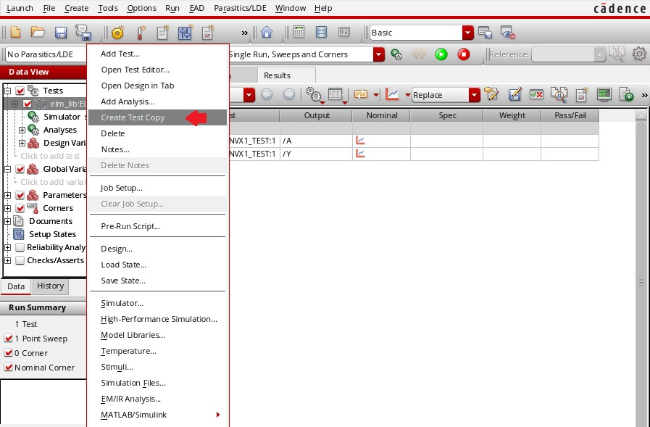
Figure 42: ADE XL Copy Test
Now add a design variable. In your new test copy, expand Design Variables and click to add a variable. The following form (Fig. 43) appears:
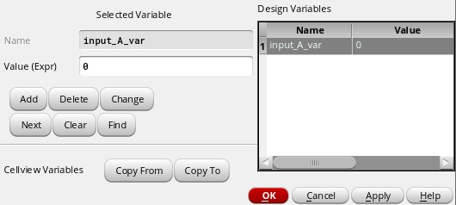
Figure 43: Edit Design Variables Form
Add a variable called input A var within an initial value of 0. Then, click OK.
Now expand Analysis and click Add analysis. The following form (Fig. 44) appears:
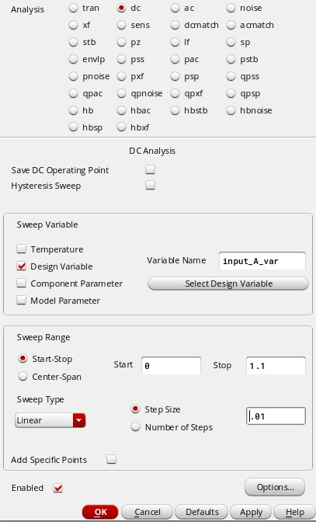
Figure 44: Configure Analysis form
Select the DC Analysis and add the Sweep Variable as the Design Variable input A var. Set the Sweep Range Start-Stop to start at 0 and Stop at 1.1. The sweep Type will be Linear with a step Size of 0.01.
Enable this analysis and click OK.
Before we run the simulation though, we need to specify which input we will get the design variable value. Right click on your test and select Stimuli (see Fig. 45).
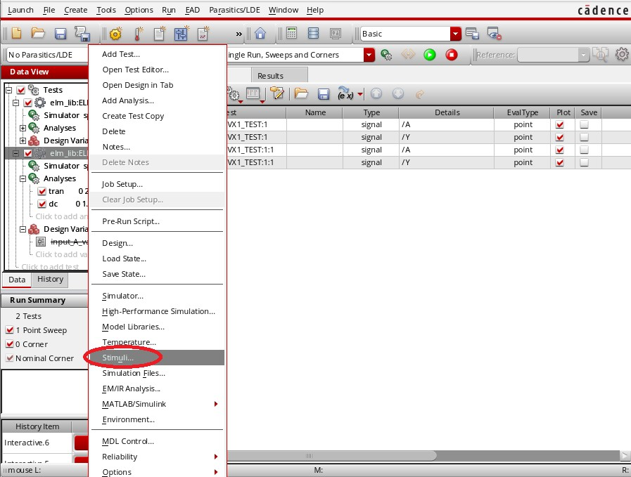
Figure 45: ADE XL - Configure Stimuli
Select input A. Keep all settings and add the Design Variable “ input A var” in the DC voltage box as shown in Fig. 46.
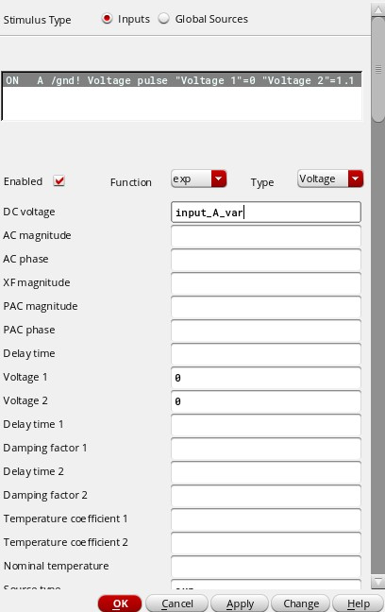
Figure 46: Configure Input Stimuli
This value will be used in the dc analysis. Click OK.
You are ready to run your first DC Sweep simulation. Click on the green start icon.
Once the test is complete, open the waveform viewer and you’ll observe both transient and dc sweep analysis waveforms.
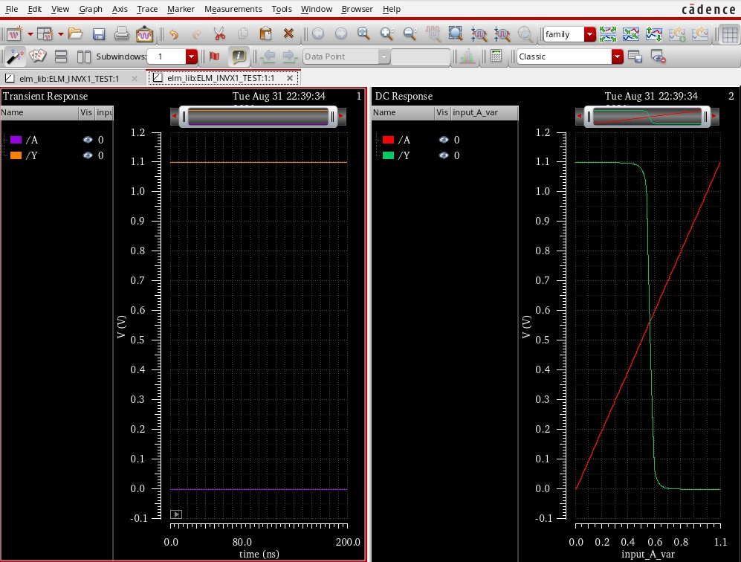
Figure 47: Waveform Results for Transient and DC Analysis
Now, we will measure the midpoint voltage value. Go to Browser → Results → Open Results. Select the PSF database. Then select the dc folder just like shown in Fig.48. Again you will see a menu to the left of the screen. Select Y, right click and select calculator.
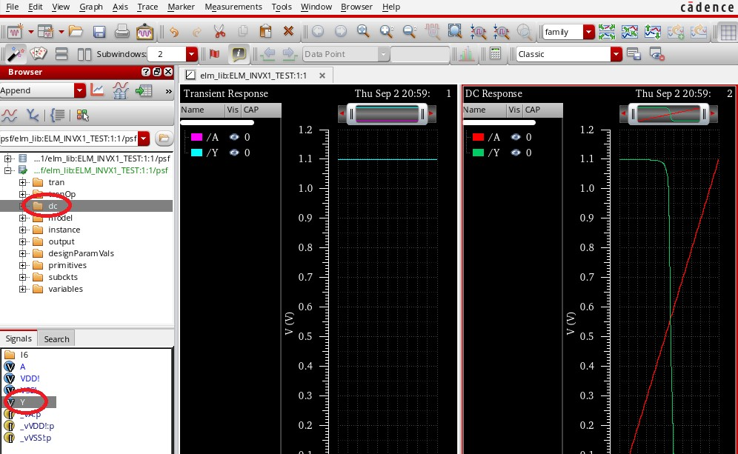
Figure 48: DC Y calculator
In the function panel, look for Intersect. Make sure that in the function panel you have signal1 as Y and signal2 as A. Your calculator window should look exactly like in Fig.49
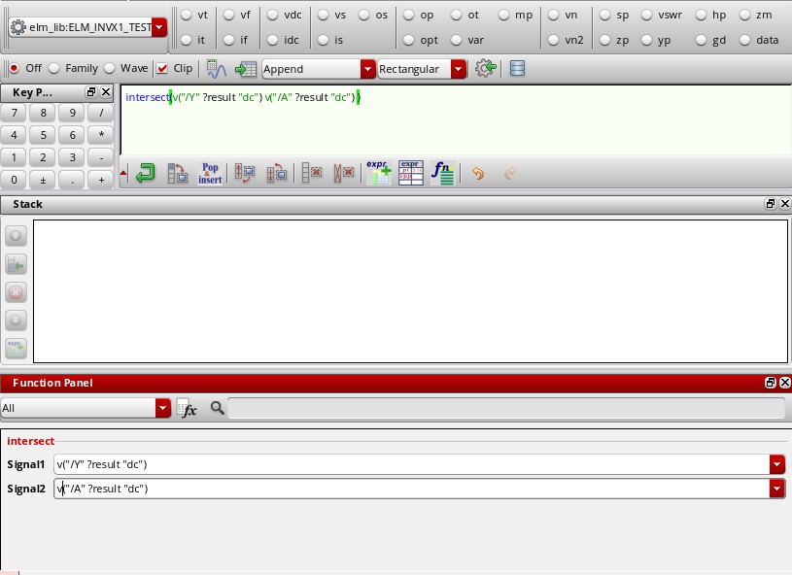
Figure 49: Intersection Function in Function Panel
Now, you may proceed to make this an expression and call it “midpoint voltage”. Now, click the save button. Get A sign-off from the instructor or TA.

Creating Your Own Tests to Collect Data
We covered a small tutorial on how to create a small test for RiseTime. How you will make tests for more RiseTimes, FallTimes and their delays for nominal and worst cases using a load or no load capacitor (All cases are shown in Table 1. We will be doing the first one together, you should be looking back at previous steps if you can’t remember how to do some things) and the rest will be on your own. Let’s begin!
Table 1: Inverter Results
 | Vdd (V) | Temp (C) | Load (fF) | RiseTime | FallTime | T P,HL | T P,LH
Nominal | 1.1 | 25 | 0
 | 1.1 | 25 | 120
Worst Case | 1 | 125 | 0
 | 1 | 125 | 120
Create a copy of your very first test example and rename it Nominal RiseTime. Then, Right click on it and select Open Test Editor Just like shown in Fig.50. (We copy because most of the initial set up is already done for you. However you must edit some parameters for each case).
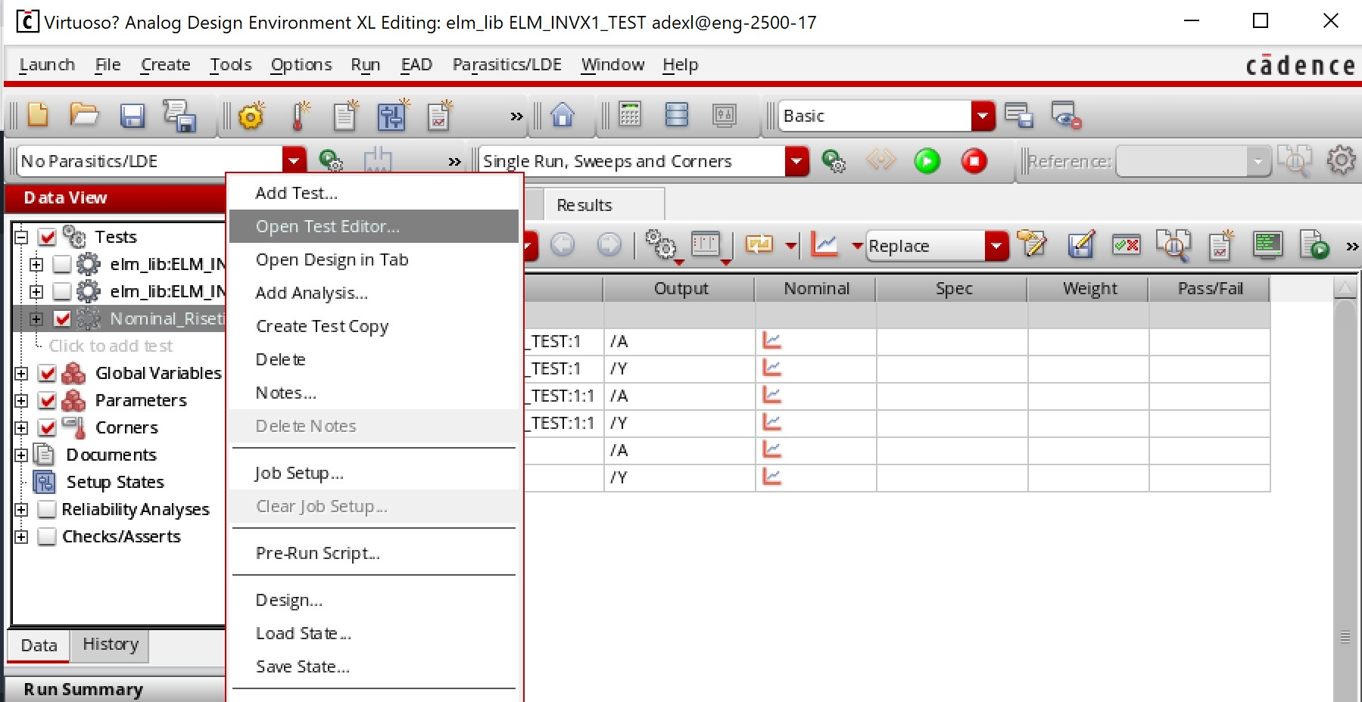
Figure 50: Copy For New Test
Now change the temperature to 25 and the CAP to 0. Then navigate to Setup → Stimuli (You don’t have to change anything for the nominal tests but when you create the worst case test you will have to change the voltage from 1.1 to 1 for now just close it. (Reminder: when you make these changes for the worst case, don’t forget to always click Apply when you make a change).
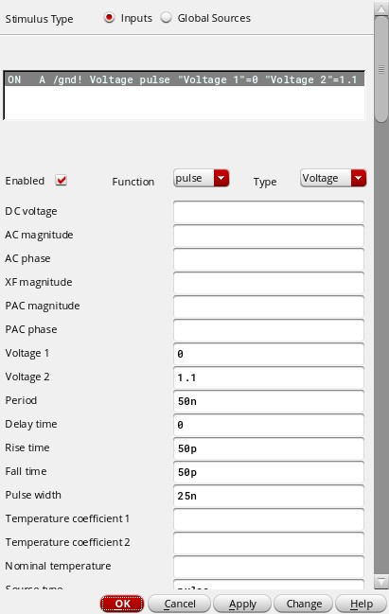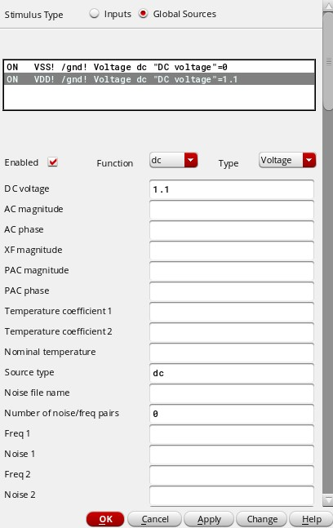
Figure 51: Nominal Stimuli Inputs Figure 52: Nominal Stimuli Global
You can close out of these and start the simulation using the green button we have been using. Make sure you select the test you want to perform otherwise all tests will run at the same time. After running the simulation, plot it, get the results for tran, right click on Y and go to the Calculator. We will revisit RiseTime again using less steps since it was explained in detail in the example.
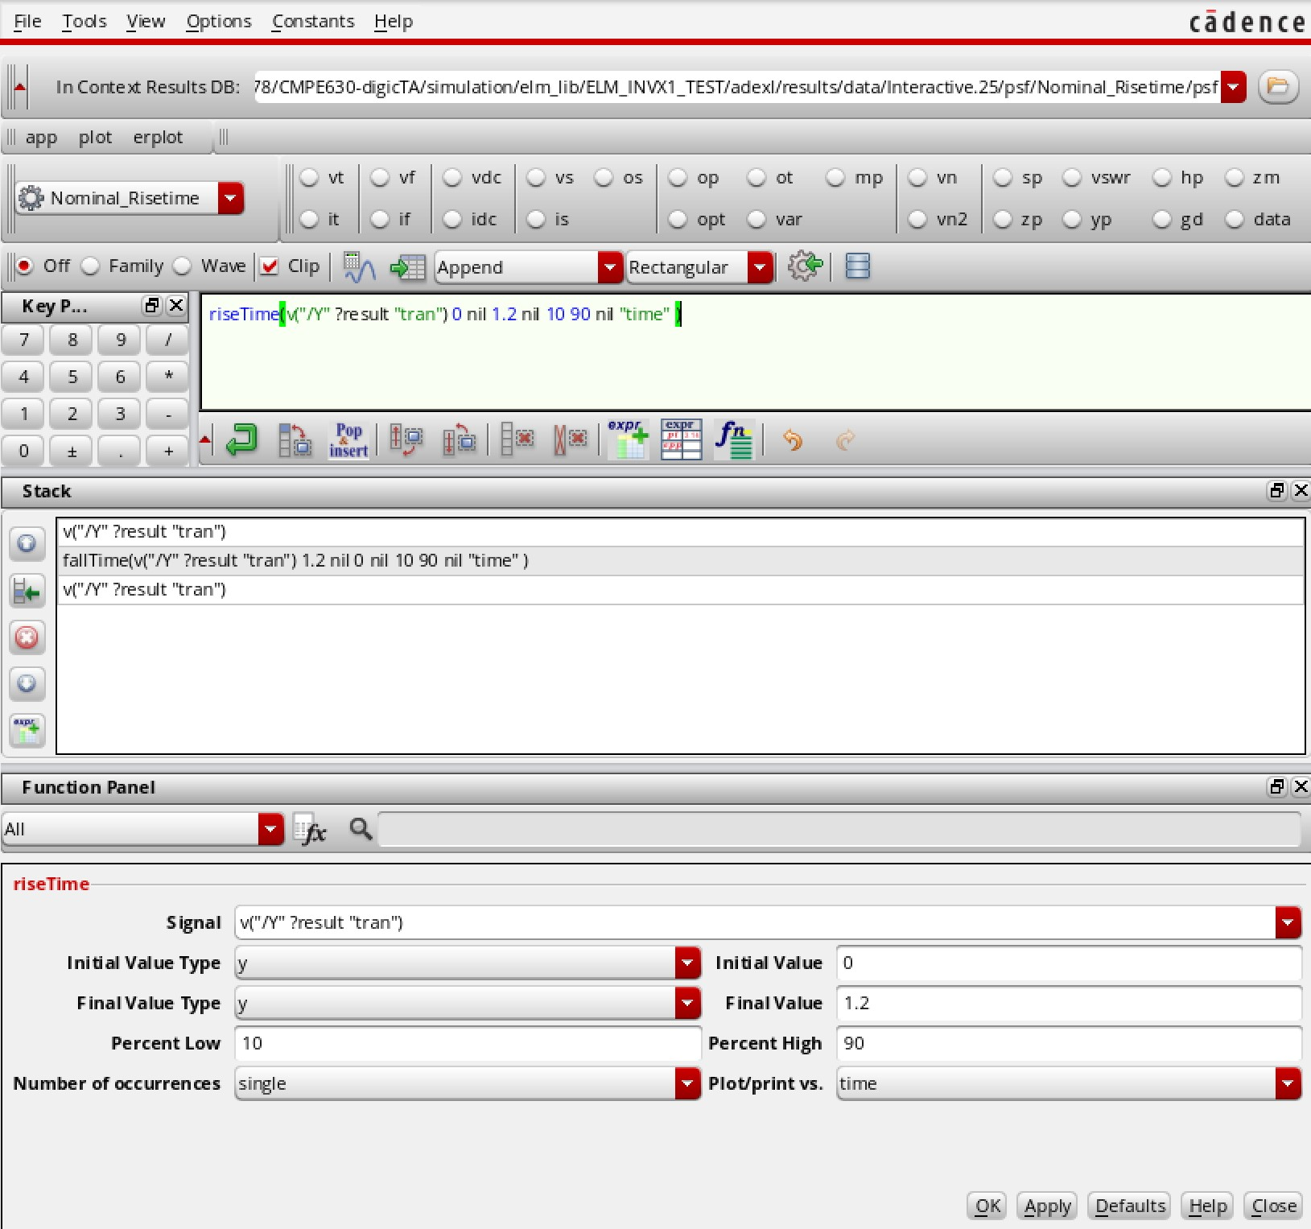
Figure 53: Nominal RiseTime Function
You may check the value using the Evaluate the buffer and display the results in a table. Then go to the expressions tab. Deselect any expressions that exist and add the new expression and rename E0 to Nominal RiseTime. If you make a mistake you may erase the expression with the button next to the one that adds.
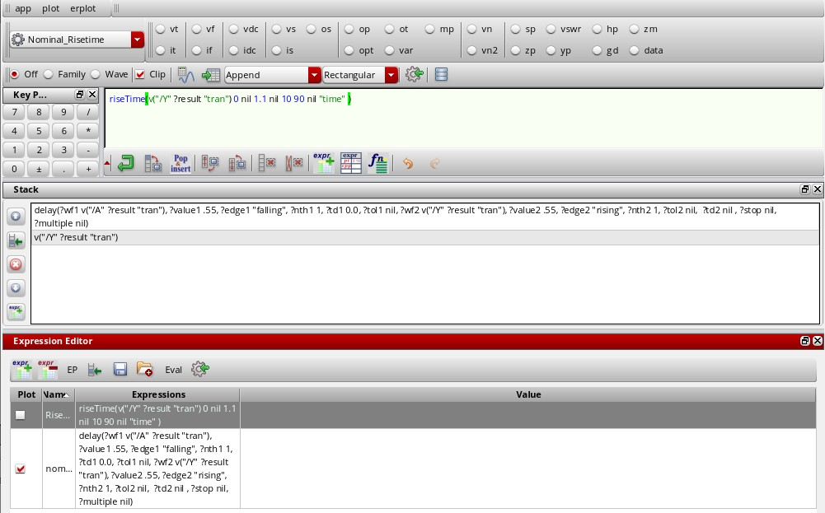
Figure 54: Nominal RiseTime Expression
Be | sure | to | not | close | your | cal | cu
la | tor | this
Follow the same steps for the calculator as mentioned previously (time). After that you may go back to the calculator and the function panel, select All and look for the delay function.
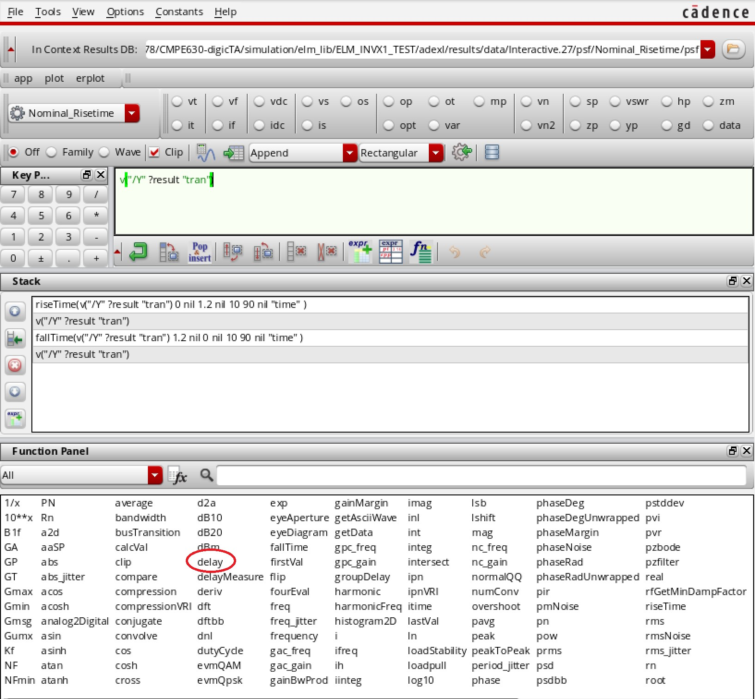
Figure 55: Nominal RiseTime Delay
de | lay | function you will change the | thresh | old | value | to | half | the | sup | ply | volt | age
In the, which in this case is half of 1.1 or .55.
prop | aga | tion | de | lays | (de | noted | as | T
ris
Important: We will use the delay function to measure P). For this test (nominal Rise time) we want to measure how long it takes for the output to rise once the input changes. We will roughly estimate that logic low is any voltage below half of the threshold and logic high is any voltage above half of the threshold. In order to measure propagation delay low to high (T P,LH) for this inverter, measure the time it takes for output Y to reach logic level high after input A has reached logic level low. To do so, we will use falling as the edge type of input A and ing as the edge type of output Y. Make the changes and click apply. The window should look just like Fig. 56
Note: Edge types for Propagation delay from high to low (T P,HL) is the opposite.
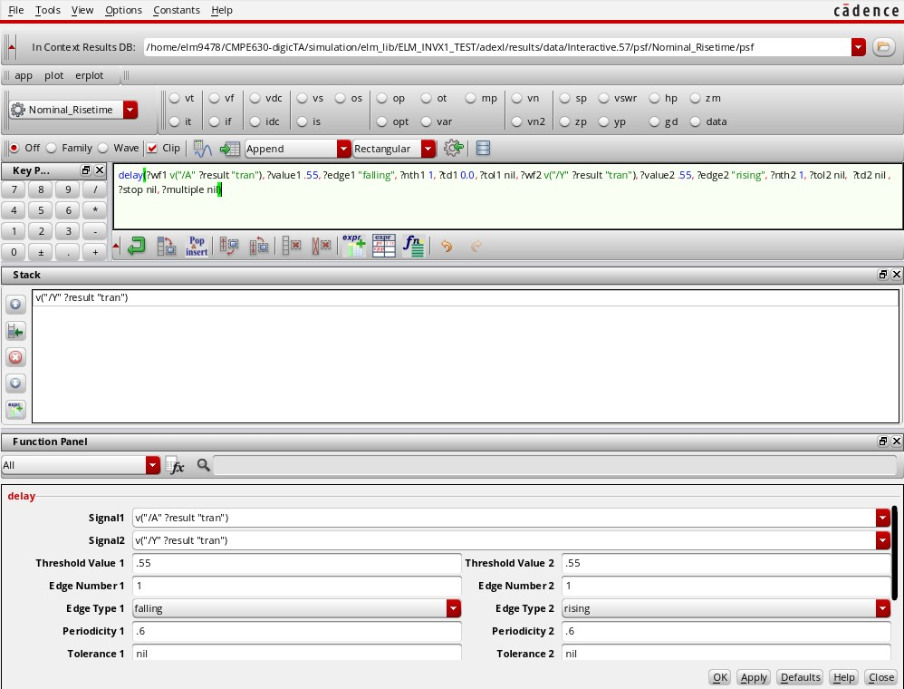
Figure 56: Nominal RiseTime Delay
Follow the same Expression convention. This completed test for the nominal rise time. Your results should mirror the figure below, except that numbers will appear instead of the blue boxes on your screen (see Fig. 57).
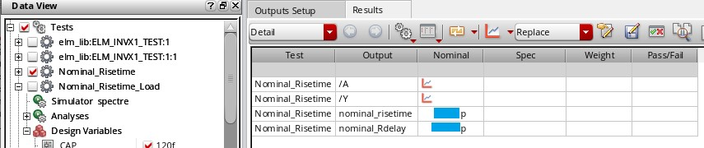
Figure 57: Nominal RiseTime Delay Final Test Output
CAP | to | 120f
Now, copy this test, rename it to Nominal Risetime load, and change the. When you run this test, make sure that the CAP variable under Design Variables is checked off, otherwise the simulation will not incorporate it and your results will look identical to the previous step.
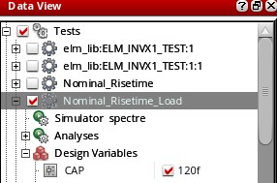
Figure 58: CAP Variable Check
Make sure you have a total of 10 separate tests. The first one is the example that you use to copy for the next tests you do on your own. The second test is the Midpoint Voltage test and the remaining 8 tests are to fill Table 1. The third test is what we just did. You must fill up Table 1 for sign-off and include it in your report.
- Initial test example (should be completed)
- Midpoint Voltage (should be completed)
- Nominal RiseTime (should be completed)
- Nominal RiseTime with Load
- Nominal FallTime
- Nominal FallTime with Load
- Worst Case RiseTime
- Worst Case RiseTime with Load
- Worst Case FallTime
- Worst Case FallTime with Load
 | Please | check | and | read | re | minders | on | the | next | page | be | fore | mov | ing | on!
REMINDERS AND ADVICE:
- The load is a CAP with 120 fF. No load is a CAP with 0 fF (i.e., no output capacitor).
  - This is not the same as the initial test example in which we used 100 fF!
- The worst case conditions are Vdd = 1 V and Temp = 125 C.
- FallTime tests measure Fall Time and T PHL.
fall
  - Make sure to use Time (not riseTime) to meaure fall time. Be sure to adjust the delay function for measuring T PHL (see here).
For | Fall | Time, | set | per | cent | high | = | 10% | and | per | cent | low | = | 90
  - %.
  - For Fall Tests, you need to swap the value of voltage 1 and voltage 2 for the input stimuli A
  - If you are curious/having trouble with any function, click the help button.
- For this lab, you may want to disable Global Variable (It is underneath Tests in the dataview window).
  - Global variables force the same value on the parameters (i.e., CAP and temp) for all of the tests. We don’t want that for this lab since we are testing different load and temperature values.
- Another thing you can do instead of manually creating each test is to make test copies and edit the copies.
  - Right click on the test that you want to duplicate and then click on make test copy.
  - A new copy of the test should appear below the original one. It will have the same properties as the original one including CAP, temp, inputs stimuli, and all the expression for calculation. For instance, you can make a duplicate of nominal rise time, rename it worst case rise time, and only change the temp and stimuli because everything else should be the same.
The finalized tests should look very similar to Fig. 59 except that you should have your own values. (Please only run the midpoint test and the 8 tests relevant to the table when getting a sign-off).
Take a screenshot of each test with all your results. Your report will require it.
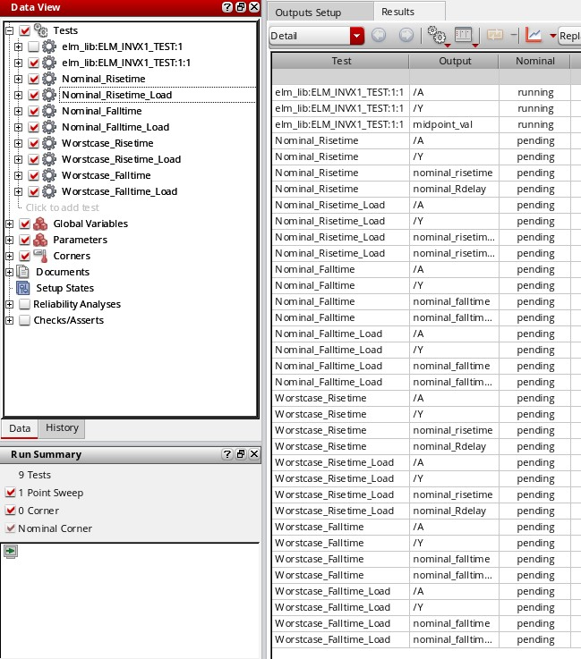
Figure 59: Final Test
Fill up the overall results table (Table 3) using the equations provided in this manual. The completed Table 2 and 3 are required in the lab report!

Table 2: Inverter Results
 | Vdd (V) | Temp (C) | Load (fF) | RiseTime | FallTime | T P,HL | T P,LH
Nominal | 1.1 | 25 | 0 | 15.09p | 13.34p | 13.57p | 25.05n
 | 1.1 | 25 | 120 | 2.514n | 2.399n | 1.149p | 882.5p
Worst Case | 1 | 125 | 0 | error | error | 15.74p | 25.05n
 | 1 | 125 | 120 | error | error | error | error
Table 3: Overall Results
 | VDD (V) | Temp (C) | Load (fF) | Finput,max | Fthroughput,max
Inverter | 1 | 125 | 0 | error | $$3.988 × 10^7 Hz$$
 | 1 | 125 | 120 | error | error
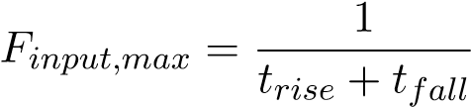 (1)
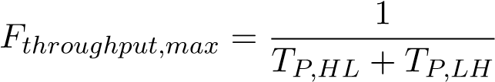 (2)

Worst Case: $VDD = 1V, Temp = 125°C, Load = 0 fF$
$trise = error$
$tfall = error$
$TP,HL = 15.74p = 15.74 × 10^(-12) s$
$TP,LH = 25.05n = 25.05 × 10^(-9) s$

$$F_{throughput,max}=1/\left(TP,HL+TP,LH\right)$$
$$F_{throughput,max}=1/\left(15.74×10^{\left(-12\right)}+25.05×10^{\left(-9\right)}\right)$$
$$F_{throughput,max}=1/\left(25.06574×10^{\left(-9\right)}\right)$$
$$F_{throughput,max} ≈ 3.988 × 10^7 Hz$$

Since trise and tfall are errors, Finput_max cannot be calculated.

Worst Case: VDD = 1V, Temp = 125°C, Load = 120 fF

trise = error
tfall = error
TP,HL = error
TP,LH = error

Since all values are error, both Finput_max and Fthroughput_max cannot be calculated.

Questions
- What are the regions of operation of an inverter? Describe the mode of operation for each transistor for each region. Use the VTC curve you saw in class to explain.
- Draw the waveform that would result from a DC sweep of the input of the following circuit.
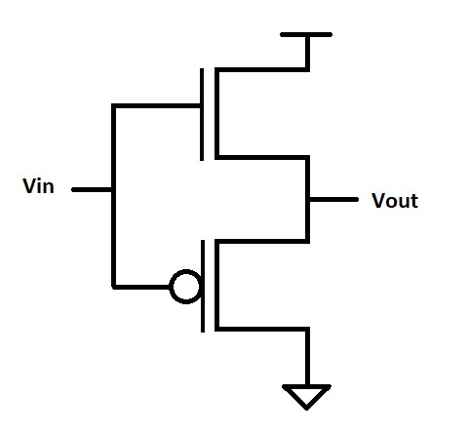

Answers to the Questions

1. What are the regions of operation of an inverter? Describe the mode of operation for each transistor for each region. Use the VTC curve to explain.
A CMOS inverter consists of a PMOS pull-up transistor and an NMOS pull-down transistor. The operation of the inverter is divided into three regions based on the input voltage (VinV_{in}) and the output voltage (VoutV_{out}). The Voltage Transfer Characteristic (VTC) curve defines these regions:

Region 1: Cutoff Region (Logic HIGH Output)
- Condition: Vin≈0VV_{in} \approx 0V (close to ground)
- Operation:
  - The NMOS transistor is OFF (Cutoff mode) because VGS<VthV_{GS} < V_{th}.
  - The PMOS transistor is ON (Saturation mode) because VSG>VthV_{SG} > V_{th}.
  - Since the NMOS is OFF, no current flows through it, and the PMOS pulls VoutV_{out} to VDDV_{DD} (logic HIGH).
- Summary: Vout=VDDV_{out} = V_{DD} (HIGH output), NMOS OFF, PMOS ON.

Region 2: Transition Region (Both Transistors Conduct)
- Condition: VinV_{in} is at the midpoint (typically VDD/2V_{DD}/2)
- Operation:
  - The NMOS is in Saturation mode because VGS>VthV_{GS} > V_{th} and VDS>VGS−VthV_{DS} > V_{GS} - V_{th}.
  - The PMOS is in Linear mode because VSG>VthV_{SG} > V_{th} and VSDV_{SD} is small.
  - Both transistors conduct, and a direct path between VDDV_{DD} and ground exists.
  - The output voltage is at an intermediate value.
- Summary: VoutV_{out} is in transition, and both transistors are partially conducting.

Region 3: Saturation Region (Logic LOW Output)
- Condition: Vin≈VDDV_{in} \approx V_{DD} (close to supply voltage)
- Operation:
  - The NMOS transistor is ON (Saturation mode) because VGS>VthV_{GS} > V_{th}.
  - The PMOS transistor is OFF (Cutoff mode) because VSG<VthV_{SG} < V_{th}.
  - The NMOS pulls VoutV_{out} to ground.
- Summary: Vout=0VV_{out} = 0V (LOW output), NMOS ON, PMOS OFF.

2. Draw the waveform that would result from a DC sweep of the input of the circuit.
A DC sweep of the input means we gradually increase VinV_{in} from 0V to VDDV_{DD} and observe how VoutV_{out} changes.
- The Voltage Transfer Characteristic (VTC) curve of a CMOS inverter is an S-shaped curve:
  - When Vin=0VV_{in} = 0V, Vout=VDDV_{out} = V_{DD}.
  - When Vin=VDD/2V_{in} = V_{DD}/2, VoutV_{out} rapidly switches from HIGH to LOW.
  - When Vin=VDDV_{in} = V_{DD}, Vout=0VV_{out} = 0V.
The expected waveform looks like this:
Vout
|
| HIGH (VDD)
| ───────────────
| \
| \
| \
| \
| \
| ───────────
|_______________________________ LOW (0V)
|
|___________________________________________ Vin
(Transition)
- The output stays HIGH when VinV_{in} is LOW.
- The transition occurs sharply at VDD/2V_{DD}/2.
- The output stays LOW when VinV_{in} is HIGH.
Let me know if you need any additional details!

Lab Exercise Report Requirements
These are the requirements for your lab report. Please use the right format for CE lab exercise reports. This is a graduate level course and you should be equipped with a lot of knowledge to write a proper report for this class. Please follow the list of guidelines and apply as much as you can from what you already know on how to explain theory, waveforms, results, behavior, and everything else that should be inside a proper report!
Note: Proper citation is needed for all non-original figures (i.e., those that you have not made yourself).
- Cover Page
    - Name and number of the lab exercise
    - Your name, name of the instructor, and name of the TAs
    - Submission date
- Table of contents
- Abstract • A description of what you did for this exercise, how you did it, and significant numerical lab results (e.g., input and throughput frequencies)
- Design Methodology • Include all necessary figures such as design schematics, symbol designs, and testbench schematics
    - Include a discussion of NMOS and PMOS IV characteristics
    - Include the inverter voltage transfer characteristics
    - Include any relevant knowledge you learned in class about basic transistors and inverters to your report
- Results and Analysis
• Simulation results include:
      - Transient simulation waveform
      - DC Analysis (sweep) waveform
      - A screenshot of all timing measurements in ADE XL
      - Statement on what midpoint voltage is
    - Completed Table 2 and 3 with proper captions (do not forget units!)
    - Provide percentage increase or decrease in the maximum operating frequency and the maximum throughput from the loaded to the worst unloaded
- Conclusion • Restate important results, how they were obtained, any uncertainties, possible improvements, and any implications.
• This should not be a copy-paste of the Abstract
- Questions
  - Re-write the question(s)
  - Answer all of the questions from the “questions” section.
- References (if needed)
- Sign-off Sheet • This is absolutely required! Lab reports will not be graded without a sign-off sheet.
Otherwise your grade will be an automatic zero.

Signoff Sheet
Students Name: Section:
Demo | Point Value | Points Earned | Date
Schematic CIW Check | 5
Transient Simulation | 5
DC Sweep Simulation with midpoint calculation | 20
Nominal Tests | 35
Worst Case Tests | 35

